AUTOMATIC TELLER MACHINE
(ATM)

CONTRIBUTION
NAME | CONTRIBUTION | SIGN.
SARVESHWAR
NEOGI (1828097)

SATYAJIT BISWAL
(1828098)

SAUMYA PRIYADARSHINI
(1828099)

SAYANTANI CHAKRABORTY
(1828100)

SHAMBHAVI SHARMA
(1828101)

SHILADITYA ROY
(1828102)

SHIVAM NARAYAN
(1828103)

SHREYO SINHAROY
(1828105)

SHWETALEENA SAHOO
(1828106)

ACKNOWLEDGEMENT

It is a great pleasure for us to acknowledge all those who have contributed towards the conception, origin and nurturing of this project that is on System analysis the “ATM Management System”. The way can’t walk itself. We have to walk on it. For that we must have a guide. Many guides have contributed to the successful completion of the project. We would like to place on record my grateful thanks to each one of them who were a part of this project. Before we get into thick of the thing, we would like to add a few heartfelt words for the people who gave us unending time support whichever and whenever necessary.

Our grateful thanks go to our Dept., which provides us an opportunity as a project subject in 3rd Semester to develop a report work skill in this System analyzing. Our special thanks go to Mr.M.K. Gourisaria Sir , to give his expert guidance to us whenever necessary.

PREFACE

Object-oriented programming – As the name suggests use object in programming. Object-oriented programming aims to implement real-world entities like inheritance, hiding, polymorphism, etc in programming. The main aim of OOP is to bind together the data and the functions that operate on them so that no other part of the code can access this data except that function.

A Class is a user-defined data-type which has data members and member functions.
Data members are the data variables and member functions are the functions used to manipulate these variables and together these data members and member functions define the properties and behaviour of the objects in a Class.

In the above example of class Car, the data member will be speed limit, mileage etc and member functions can apply brakes, increase speed etc.

ABSTRACT

This report attempts to understand the design of an Automated Teller Machine (ATM) system, a device used by bank customers to process account transactions. Typically, a user inserts into the ATM a special plastic card that is encoded with information on a magnetic strip. The strip contains an identification code that is transmitted to the bank's central computer by modem. To prevent unauthorized transactions, a personal identification number (PIN) must also be entered by the user using a keypad. The computer then permits the ATM to complete the transaction; most machines can dispense cash, accept deposits, transfer funds, and provide information on account balances. Banks
have formed cooperative, nationwide networks so that a customer of one bank can use an ATM of another for cash access. Some ATMs will also accept credit cards for cash advances. The first ATM was installed in 1969 by Chemical Bank at its branch in Rockville Centre, New York. A customer using a coded card was dispensed a package containing a set sum of money.

CONTENT
SNO. | TITLE | PAGE NO.
1. | Introduction | 8
2. | Objective | 10
3. | Project Planning | 12
4. | Code Print | 23
5. | Output Screenshot | 47
6. | Limitations | 52
7. | Scope Of Improvement | 53
8. | Conclusion | 54
9. | Bibliography | 55

INTRODUCTION

  - Project Summary

An automated teller machine (ATM) or automatic banking machine (ABM) is a computerised telecommunications device that provides the clients of a financial institution with access to financial transactions in a public space without the need for a cashier, human clerk or bank teller. On most modern ATMs, the customer is identified by inserting a plastic ATM card with a magnetic stripe or a plastic smart card with a chip, that contains a unique card number and some security information such as an expiration date or CVVC (CVV). Authentication is provided by the customer entering a personal identification number (PIN).

1.2 Purpose

Using an ATM, customers can access their bank accounts in order to make cash withdrawals (or credit card cash advances) and check their account balances as well as purchase cellphone prepaid credit. If the currency being withdrawn from the ATM is different from that which the bank account is denominated in (eg: Withdrawing Japanese Yen from a bank account containing US Dollars), the money will be converted at a wholesale exchange rate. Thus, ATMs often provide the best possible exchange rate for foreign travelers and are heavily used for this purpose as well.

1.3 Scope

The main purpose of the ATM division and information service is to provide the customers financial flexibility, worldwide acceptance and round-the clock convenience. Bank issues only VISA Credit Cards, the renowned Credit Card brand. Cardholders can purchase goods/services up to the credit limit and can reuse the credit facility upon repayment. Credit Card is a safer substitute to cash and is the major mode of payment worldwide. Standard Chartered Bank is the first to introduce the TAKA CREDIT CARD. The card is issued basically to a person’s name and the specific person can use the card in anywhere in Bangladesh.


OBJECTIVE
Using an ATM, customers can access their bank accounts in order to make cash withdrawals (or credit card cash advances) and check their account balances as well as purchase cellphone prepaid credit. If the currency being withdrawn from the ATM is different from that which the bank account is denominated
The main purpose of the ATM division and information service is to provide the customers financial flexibility, worldwide acceptance and round-the clock convenience. Bank issues only VISA Credit Cards, the renowned Credit Card brand. Cardholders can purchase goods/services up to the credit limit and can reuse the credit facility upon repayment. Credit Card is a safer substitute to cash and is the major mode of payment worldwide. Standard Chartered Bank is the first to introduce the TAKA CREDIT CARD. The card is issued basically to a person’s name and the specific person can use the card in anywhere in Bangladesh. The business activity of Premier Bank Credit Card section is to keep the records of all sales and customers’ requests, the information of cardholders and reports them to necessary documents.

PROJECT PLANNING
Project planning must deals with the following things:-

Project Complexity: - Project complexity has a strong effect but is heavily influenced by past practitioner experience. ➢

Project Size: - As size increases the inter-dependency of elements also grow. Watch out for scope creep.
The degree of structural uncertainty: - the degree to which requirements are solidified and the ease of functional decomposition.The purpose of project planning is to ensure that the end result is completed on time, within budget, and exhibits quality!

Stages of Software Lifecycle:

• Software Requirement Analysis

This is the first stage of the project, which involves interaction with the customer to understand his/her needs, requirements, information, required functions, performance and interfacing . For this purpose requirement analyst will arrange a meeting for gathering information and additional details for software development. After completing requirement
gathering tasks developer team will take a look for understand how requirements can be computerized. The requirement is documented in the form of a Software Requirement Specification (SRS) which is then presented to the customer for review.

• Design

Beginning once software requirements have been analyzed and specified, software design is the first of three technical activities – design, code generation, and test – that are required to build and verify the software.

Design is multi level process which defines following details:
- Data Design ▪
- Architecture Design ▪
- Interface Design
- Component level Design

• Development

The design must be translated into a machine-readable form. The coding step performs this task. In this stage, the developers will actually code the programs. The specifications arrived at the design stage for each and every function will be converted to code using tools that are finalized for the implementation of the Software(ATOM). At this stage the testing methodology to be adopted will be finalized. For each program test cases will be prepared and for each of these test cases, test data will also be prepared. The actual developers will do a first current checking at this stage to see that the programs written by them are error free.

• Testing

In this stages the test group of the development team, using the cases and the test data already prepared will test the programs. Only after all the functions are tested singularly, an integrated testing will be performed to see that inter-function dependability is satisfied. Separate test cases and test data will be worked out for the integrated testing.

• Data Creation

For software, data is most important part. Data is information which is handled by software. So before coding software, all master table data will have to be created.

• Implementation

Now the implementation of software is to be done by programmers. All the requirements and information gathered by the analyst is now take actual image in form of software. After making software it is uploaded in to the system so users, for whom software is developed, can use the software.
Once we examine that the project is feasible, we undertake project planning. The table below describes how we planned our project.

• Data Creation

For software, data is most important part. Data is information which is handled by software. So before coding software, all master table data will have to be created.

• Implementation

Now the implementation of software is to be done by programmers. All the requirements and information gathered by the analyst is now take actual image in form of software. After making software it is uploaded in to the system so users, for whom software is developed, can use the software.
Once we examine that the project is feasible, we undertake project planning. The table below describes how we planned our project.

ATM SYSTEM ARCHITECTURE
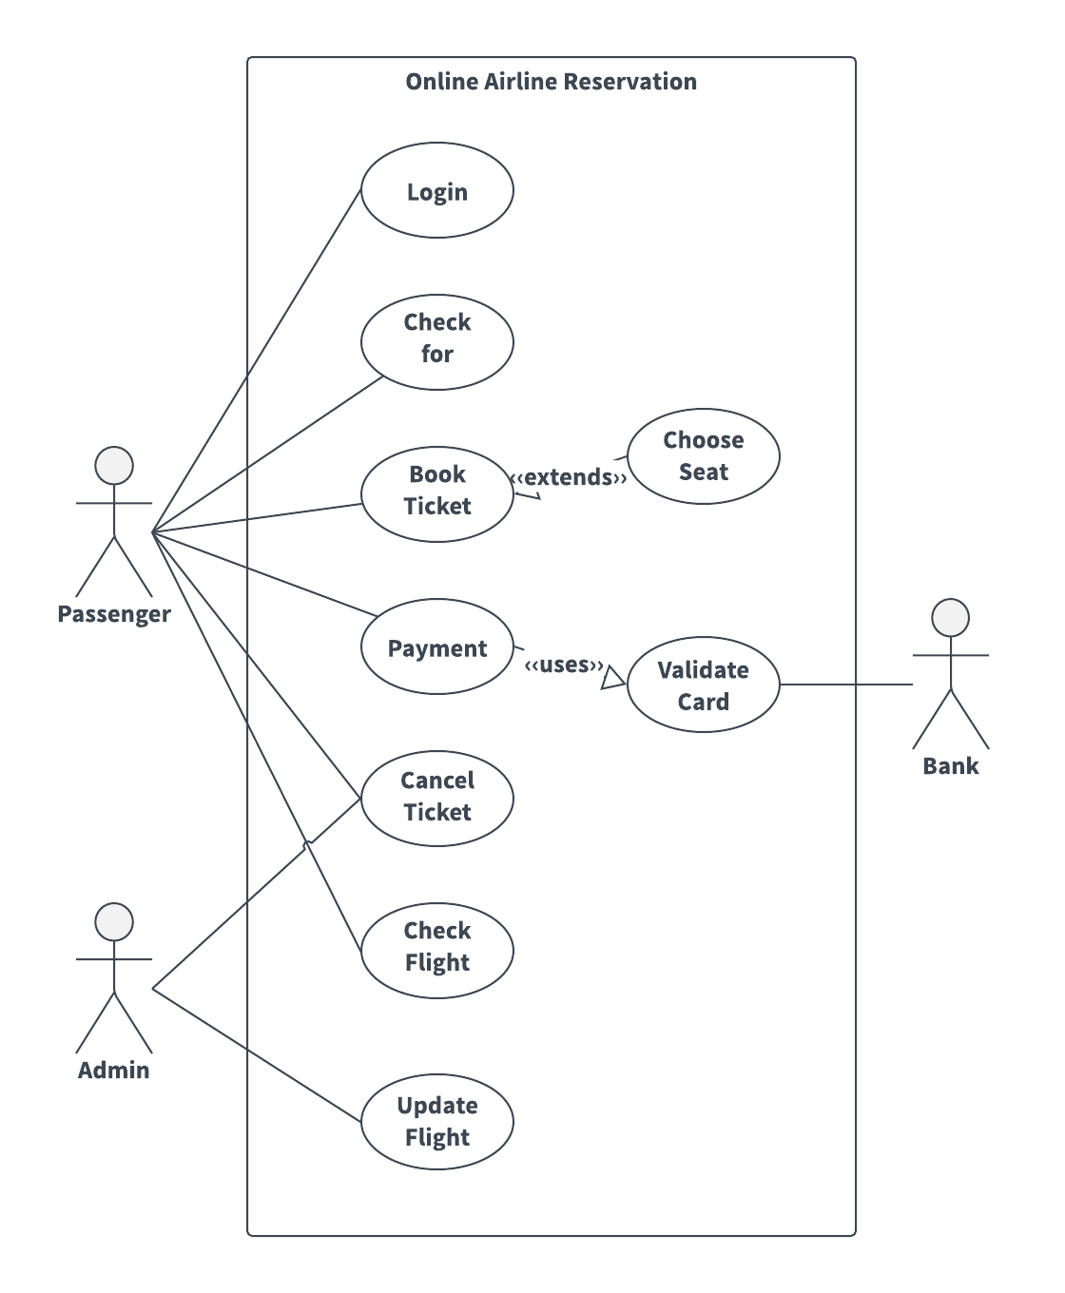

ACTIVITY DIAGRAM
An Activity Diagram is essentially a flow chart showing flow of control from activity to activity. They are used to model the dynamic aspects of as system. They can also be used to model the flow of an object as it moves from state to state at different points in the flow of control.
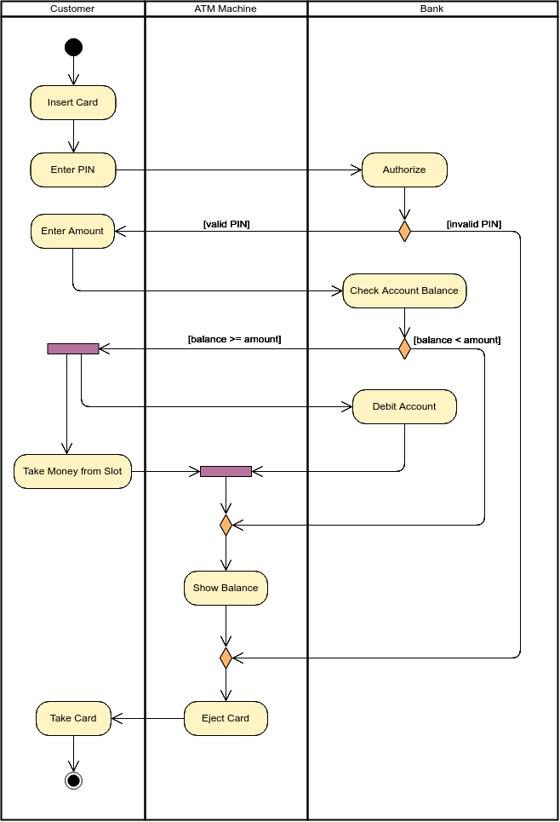
Class diagram/ E-R Diagram
Class diagrams are the most common diagrams found in modeling object-oriented systems. A class diagram shows a set of classes, interfaces, and collaborations and their relationships. Graphically, a class diagram is a collection of vertices and arcs.

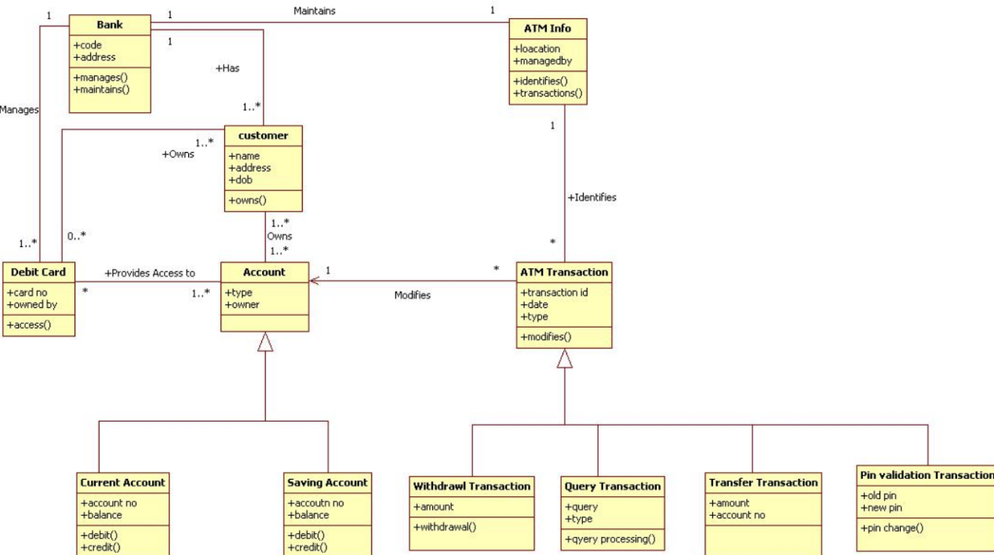
Class Diagram is a graph that represents the relationship between the classes and represents their semantics.  Here ATM works as main class. All other classes are related with this class. ATM does following operations:
- Verify_pin()
- Check_balance()
- Cash_withdrawal()
- Ministatement()
- Print_receipt()
- Another_transaction()

ATM card related with ATM through many to many relationship. It does following operations:
- Insert_card_into_ATM()
- Insert_Pin_code()
- Remove_card_after_transaction()

❖ Account holder related with ATM through many to many relationship. It performs following operations: - Withdrawal() - Transfer()
- Balance_inquiry()

❖ ATM server related with ATM by one or many to one or many relationship. It also performs some task shown as below:
- Updating_after_each_transaction()
- Changing_the_pin_code()
- Showing_exact_balance_after_each_transaction()

Bank Manager associated with ATM through one or many to one relationship. ATM is not related with this class, but dependent on this class. So there is a dependent relationship assigned to them. Bank Manager does following tasks:

- Managing_different_accounts()
- Maintaining_sufficient_balance_in_ATM()
- Access_to_the_ATM_server()

Here, a class Bank not related to any of the class, but some classes are dependent on these classes which are shown as dependent relationship with it. Normally this class performs following operations:

- Create_Account()
- Accessing_Account()
- Providing_ATM_card()

System Activity or Object interaction Diagram
An Interaction diagram shows an interaction, consisting of a set of objects and their relationships, including the messages that may be dispatched among them. Interaction diagrams are used for modeling the dynamic aspects of the system.
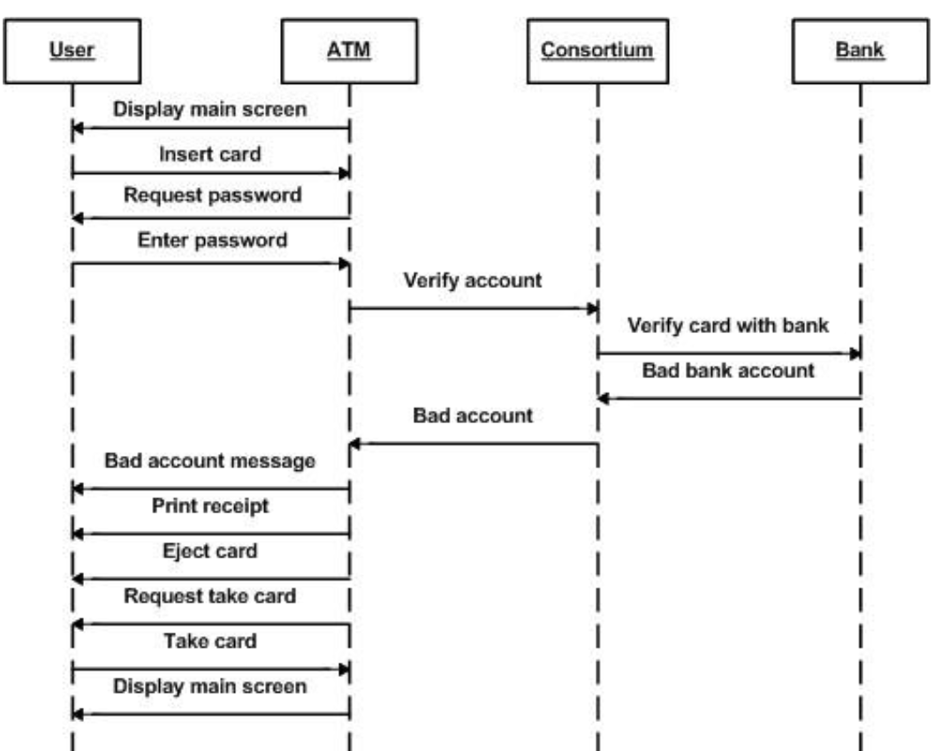
Data Flow Diagram (0 and 1 level)
A graphical tool used to describe and analyze the moment of data tOBSough a system manual or automated including the process, stores of data, and delays in the system. Data Flow Diagrams are the central tool and the basis from which other components are developed. The transformation of data from input to output, tOBSough processes, may be described logically and independently of the physical components associated with the system. The DFD is also known as a data flow graph or a bubble chart. A graphical tool used to describe and analyze the moment of data through a system manual or automated including the process, stores of data, and delays in the system. Data Flow Diagrams are the central tool and the basis from which other components are developed. The transformation of data from input to output, through processes, may be described logically and independently of the physical components associated with the system. The DFD is also known as a data flow graph or a bubble chart.

SOURCE CODE
#include <iostream>
#include <iomanip>
#include <time.h>
#include <fstream>
#include <conio.h>
#include <string.h>
#include <stdlib.h>
#include<process.h>
#include<direct.h>
using namespace std;

//==================================================================================================
class Bank //abstract base class
{
public:
double startBalance;
string COKAccountHolders;
double limit;

//virtual bool Deposit(double Dvalue)=0;
// manage deposit
//virtual bool Transaction(double Dvalue)=0;
// use as necessary
//virtual void Display_accountBalance()=0;
// Show the balance in a nice way
//virtual void SetLimit(double NewLimit)=0;
//virtual double GetLimit()=0;

};

//==================================================================================================
class ATMAccountHolders:public Bank
{
public:
string accountHolders;
string accountHoldersAddress, branch;
int accountNumber;
double startBalance;
double accountBalance;
double accountInterest;
double amount;
int count;

public:
//void Display_accountBalance();
void deposit();
void withdraw();
void details();
void payBills();
void accountExit();
void changepin();
void interest();

ATMAccountHolders()
{
accountNumber = 5678;
accountHolders = "Shiladitya Roy";
accountHoldersAddress = "KP(9B)";
startBalance = 60000.00;
accountBalance = 20000.00;
branch = "SBI";
amount = 20000;
}
};
/*==================================================================================================*/

void ATMAccountHolders::interest()
{
system("cls");

cout<<"\n\xB2\xB2\xB2\xB2\\xB2\xB2\xB2\xB2\ATM ACCOUNT INTEREST PAYMENT\xB2\xB2\xB2\xB2\\xB2\xB2\xB2\xB2\\n\n";

cout<<"\tThe Interest is calculated over the last SIX months on the average account balance\n";

cout<<"\n\t\tInterest Rate payable is 10% per annum."<<endl;

cout<<"\t\tView the accumulated interest?
Press 1 for Yes OR 0 for NO.\n\n";

cout<<"\xdb\xdb\xdb\xdb\xdb\xdb\xdb\xdb\xdb\xdb\xdb\xdb\xdb\xdb\xdb\xdb\xdb\xdb\xdb\xdb\xdb\xdb\xdb\xdb ATM ACCOUNT INTEREST PAYMENT \xdb\xdb\xdb\xdb\xdb\xdb\xdb\xdb\xdb\xdb\xdb\xdb\xdb\xdb\xdb\xdb\xdb\xdb\xdb\xdb\xdb\xdb\xdb\xdb\n\n";

cout<<"\n\nThe Names of the Account Holders
are :"<<accountHolders<<"\n\n";

cout<<"\tThe Account Holders' address is :"<<accountHoldersAddress<<"\n\n";

cout<<"\tThe Branch location is :"<<branch<<"\n\n";
cout<<"\tAccount number :"<<accountNumber<<"\n\n";
cout<<"\xdb\xdb\xdb\xdb\xdb\xdb\xdb\xdb\xdb\xdb\xdb\xdb\xdb\xdb\xdb\xdb\xdb\xdb\xdb\xdb\xdb\xdb\xdb\xdb\xdb\xdb\xdb\xdb\xdb\xdb\xdb\xdb\xdb\xdb\xdb\xdb\xdb\xdb\xdb\xdb\xdb\xdb\xdb\xdb\xdb\xdb\xdb\xdb\xdb\xdb\xdb\xdb\xdb\xdb\xdb\xdb\xdb\xdb\xdb\xdb\xdb\xdb\xdb\xdb\xdb\xdb\xdb\xdb\xdb\xdb\n\n";

cout<<"\tStarting account balance :$"<<startBalance<<"\n\n";

cout<<"\tPresent available balance :$"<<accountBalance<<"\n\n";

accountInterest=accountBalance+(accountBalance*1.050);

cout<<"\tPresent available balance + interest for 6 months :$"<<accountInterest<<"\n\n";

cout<<"Press any key to Return to the Main Menu\n\n";

system("PAUSE");

}
//==================================================================================================

//==================================================================================================

void ATMAccountHolders::deposit()
{

system("cls");

cout<<"\n\xdb\xdb\xdb\xdb\xdb\xdb\xdb\xdb\xdb\xdb\xdb\xdb\xdb\xdb\xdb\xdb\xdb\xdb\xdb\xdb\xdb\xdb\xdb\xdb ATM ACCOUNT DEPOSIT SYSTEM \xdb\xdb\xdb\xdb\xdb\xdb\xdb\xdb\xdb\xdb\xdb\xdb\xdb\xdb\xdb\xdb\xdb\xdb\xdb\xdb\xdb\xdb\xdb\xdb\n\n";

cout<<"\n\nThe Name of the Account Holder is :"<<accountHolders<<"\n\n";

cout<<"\tThe Account Holders' address is :"<<accountHoldersAddress<<"\n\n";

cout<<"\tThe Branch location is :"<<branch<<"\n\n";
cout<<"\tAccountnumber :"<<accountNumber<<"\n\n";

cout<<"\xdb\xdb\xdb\xdb\xdb\xdb\xdb\xdb\xdb\xdb\xdb\xdb\xdb\xdb\xdb\xdb\xdb\xdb\xdb\xdb\xdb\xdb\xdb\xdb\xdb\xdb\xdb\xdb\xdb\xdb\xdb\xdb\xdb\xdb\xdb\xdb\xdb\xdb\xdb\xdb\xdb\xdb\xdb\xdb\xdb\xdb\xdb\xdb\xdb\xdb\xdb\xdb\xdb\xdb\xdb\xdb\xdb\xdb\xdb\xdb\xdb\xdb\xdb\xdb\xdb\xdb\xdb\xdb\xdb\xdb\n\n";

cout<<"\tStarting account balance :Rs."<<startBalance<<"\n\n";

cout<<"\tPresent available balance :Rs."<<accountBalance<<"\n\n";

cout<<"\tEnter the Amount to be Deposited Rs.\n\n";

double amount;
cin>>amount;
accountBalance=accountBalance+amount ;

cout<<"\n\tYour new available Balanced Amount is $"<<accountBalance<<endl ;

cout<<"\n\t\t\tThank You!\n\n"<<endl;

cout<<"Press any key to Return to the Main Menu\n\n";

}
//==================================================================================================

void ATMAccountHolders::withdraw()//Withdrawal Transactions
{

system("cls");
cout<<"\n\xdb\xdb\xdb\xdb\xdb\xdb\xdb\xdb\xdb\xdb\xdb\xdb\xdb\xdb\xdb\xdb\xdb\xdb\xdb\xdb\xdb\xdb\xdb\xdb ATM ACCOUNT WTHDRAWAL \xdb\xdb\xdb\xdb\xdb\xdb\xdb\xdb\xdb\xdb\xdb\xdb\xdb\xdb\xdb\xdb\xdb\xdb\xdb\xdb\xdb\xdb\xdb\xdb\n\n";

cout<<"\n\nThe Name of the Account Holder is :"<<accountHolders<<"\n\n";

cout<<"\tThe Account Holders' address is :"<<accountHoldersAddress<<"\n\n";

cout<<"\tThe Branch location is :"<<branch<<"\n\n";

cout<<"\tAccount number :"<<accountNumber<<"\n\n";

cout<<"\xdb\xdb\xdb\xdb\xdb\xdb\xdb\xdb\xdb\xdb\xdb\xdb\xdb\xdb\xdb\xdb\xdb\xdb\xdb\xdb\xdb\xdb\xdb\xdb\xdb\xdb\xdb\xdb\xdb\xdb\xdb\xdb\xdb\xdb\xdb\xdb\xdb\xdb\xdb\xdb\xdb\xdb\xdb\xdb\xdb\xdb\xdb\xdb\xdb\xdb\xdb\xdb\xdb\xdb\xdb\xdb\xdb\xdb\xdb\xdb\xdb\xdb\xdb\xdb\xdb\xdb\xdb\xdb\xdb\xdb\n\n";

cout<<"\tStarting account balance :$"<<startBalance<<"\n\n";

cout<<"\tPresent available balance :$"<<accountBalance<<"\n\n";

cout<<"\tEnter the Amount to be Withdrawn $";

double amount;
cin>>amount;

if(amount>accountBalance||amount>10000)//Limit set at $9000 maximum after paying bills
{

system("cls");

cout<<"\n\xdb\xdb\xdb\xdb\xdb\xdb\xdb\xdb\xdb\xdb\xdb\xdb\xdb\xdb\xdb\xdb\xdb\xdb\xdb\xdb\xdb\xdb\xdb\xdb ATM ACCOUNT WITHDRAWAL \xdb\xdb\xdb\xdb\xdb\xdb\xdb\xdb\xdb\xdb\xdb\xdb\xdb\xdb\xdb\xdb\xdb\xdb\xdb\xdb\xdb\xdb\xdb\xdb\n\n";

/*cout<<"\n\nThe Name of the Account Holders are :"<<accountHolders<<"\n\n";

cout<<"\tThe Account Holders' address is :"<<accountHoldersAddress<<"\n\n";

cout<<"\tThe Branch location is :"<<branch<<"\n\n";

cout<<"\tAccount number :"<<accountNumber<<"\n\n";*/

cout<<"\xdb\xdb\xdb\xdb\xdb\xdb\xdb\xdb\xdb\xdb\xdb\xdb\xdb\xdb\xdb\xdb\xdb\xdb\xdb\xdb\xdb\xdb\xdb\xdb\xdb\xdb\xdb\xdb\xdb\xdb\xdb\xdb\xdb\xdb\xdb\xdb\xdb\xdb\xdb\xdb\xdb\xdb\xdb\xdb\xdb\xdb\xdb\xdb\xdb\xdb\xdb\xdb\xdb\xdb\xdb\xdb\xdb\xdb\xdb\xdb\xdb\xdb\xdb\xdb\xdb\xdb\xdb\xdb\xdb\xdb\n\n";

cout<<"\n\tInsufficient Available Balance in your account.\n\n"<<endl;

cout<<"\t\t\tSorry !!\n"<<endl;

system("PAUSE");
}

else
{

double b;
accountBalance=startBalance-amount ;

system("cls");
cout<<"\n\xdb\xdb\xdb\xdb\xdb\xdb\xdb\xdb\xdb\xdb\xdb\xdb\xdb\xdb\xdb\xdb\xdb\xdb\xdb\xdb\xdb\xdb\xdb\xdb ATM ACCOUNT WTHDRAWAL \xdb\xdb\xdb\xdb\xdb\xdb\xdb\xdb\xdb\xdb\xdb\xdb\xdb\xdb\xdb\xdb\xdb\xdb\xdb\xdb\xdb\xdb\xdb\xdb\n\n";
/*cout<<"\n\nThe Names of the Account Holders are :"<<accountHolders<<"\n\n";

cout<<"\tThe Account Holders' address is :"<<accountHoldersAddress<<"\n\n";

cout<<"\tThe Branch location is :"<<branch<<"\n\n";

cout<<"\tAccount number :"<<accountNumber<<"\n\n";*/

cout<<"\xdb\xdb\xdb\xdb\xdb\xdb\xdb\xdb\xdb\xdb\xdb\xdb\xdb\xdb\xdb\xdb\xdb\xdb\xdb\xdb\xdb\xdb\xdb\xdb\xdb\xdb\xdb\xdb\xdb\xdb\xdb\xdb\xdb\xdb\xdb\xdb\xdb\xdb\xdb\xdb\xdb\xdb\xdb\xdb\xdb\xdb\xdb\xdb\xdb\xdb\xdb\xdb\xdb\xdb\xdb\xdb\xdb\xdb\xdb\xdb\xdb\xdb\xdb\xdb\xdb\xdb\xdb\xdb\xdb\xdb\n\n";

cout<<"Your new available Balanced Amount is $"<<accountBalance<<endl ;

cout<<"Press any key to Return to the Main Menu\n\n";

system("PAUSE");
}

}

//=================================================================================================/*

void ATMAccountHolders::payBills()
{

system("cls");

cout<<"\n\xdb\xdb\xdb\xdb\xdb\xdb\xdb\xdb\
xdb\xdb\xdb\xdb\xdb\xdb\xdb\xdb\xdb\xdb\x\ xdb\xdb\xdb\xdb\xdb ATM BILLS PAYMENT SYSTEM \xdb\xdb\xdb\xdb\xdb\xdb\xdb\xdb\xdb\xdb\xdb\xdb\xdb\xdb\xdb\xdb\xdb\xdb\xdb\xdb\xdb\xdb\xdb\xdb\n";

cout<<"\n\nThe Names of the Account Holders are :"<<accountHolders<<"\n\n";

cout<<"\tThe Account Holders' address is :"<<accountHoldersAddress<<"\n\n";

cout<<"\tThe Branch location is :"<<branch<<"\n\n";

cout<<"\tAccount number :"<<accountNumber<<"\n\n";
cout<<"\xdb\xdb\xdb\xdb\xdb\xdb\xdb\xdb\xdb\xdb\xdb\xdb\xdb\xdb\xdb\xdb\xdb\xdb\xdb\xdb\xdb\xdb\xdb\xdb\xdb\xdb\xdb\xdb\xdb\xdb\xdb\xdb\xdb\xdb\xdb\xdb\xdb\xdb\xdb\xdb\xdb\xdb\xdb\xdb\xdb\xdb\xdb\xdb\xdb\xdb\xdb\xdb\xdb\xdb\xdb\xdb\xdb\xdb\xdb\xdb\xdb\xdb\xdb\xdb\xdb\xdb\xdb\xdb\xdb\xdb\n\n";

cout<<"Pay Electric Company electricity bill of $2000.00 now?\n\n";
cout<<"\t\tPress 1 for Yes OR Press 0 for No\n\n";

int r;
cin>>r;
if(r==1)
{
accountBalance=startBalance-2000;
system("cls");
cout<<"\n\xdb\xdb\xdb\xdb\xdb\xdb\xdb\xdb\xdb\xdb\xdb\xdb\xdb\xdb\xdb\xdb\xdb\xdb\xdb\xdb\xdb\xdb\xdb\xdb ATM BILLS PAYMENT SYSTEM \xdb\xdb\xdb\xdb\xdb\xdb\xdb\xdb\xdb\xdb\xdb\xdb\xdb\xdb\xdb\xdb\xdb\xdb\xdb\xdb\xdb\xdb\xdb\xdb\n";

cout<<"\n\tYour electricity bill of $2000.00 has been paid.\n\n";

cout<<"\tYour account new Available Balanced Amount is $"<<accountBalance<<endl ;

cout<<"\n\xdb\xdb\xdb\xdb\xdb\xdb\xdb\xdb\xdb\xdb\xdb\xdb\xdb\xdb\xdb\xdb\xdb\xdb\xdb\xdb\xdb\xdb\xdb\xdb\xdb\xdb\xdb\xdb\xdb\xdb\xdb\xdb\xdb\xdb\xdb\xdb\xdb\xdb\xdb\xdb\xdb\xdb\xdb\xdb\xdb\xdb\xdb\xdb\xdb\xdb\xdb\xdb\xdb\xdb\xdb\xdb\xdb\xdb\xdb\xdb\xdb\xdb\xdb\xdb\xdb\xdb\xdb\xdb\xdb\xdb\n\n";

cout<<"Press any key to Return to the Main Menu\n\n";
}

if(r=0)
{
cout<<"\n===========================ATM BILLS PAYMENT SYSTEM==========================\n\n";

cout<<"\n\n\tExiting Bill Payment System. Thank you!.\n\n";

cout<<"====================++THANK YOU++============================\n\n";

}
system("PAUSE");
};*/

//==================================================================================================
void ATMAccountHolders::details()
{
system("cls");

cout<<"\n\xdb\xdb\xdb\xdb\xdb\xdb\xdb\xdb\xdb\xdb\xdb\xdb\xdb\xdb\xdb\xdb\xdb\xdb\xdb\xdb\xdb\xdb\xdb\xdb ATM ACCOUNT DETAILS \xdb\xdb\xdb\xdb\xdb\xdb\xdb\xdb\xdb\xdb\xdb\xdb\xdb\xdb\xdb\xdb\xdb\xdb\xdb\xdb\xdb\xdb\xdb\xdb\n\n";

cout<<"\n\nThe Names of the Account Holders are :"<<accountHolders<<"\n\n";

cout<<"\tThe Account Holders' address is :"<<accountHoldersAddress<<"\n\n";

cout<<"\tThe Branch location is :"<<branch<<"\n\n";

cout<<"\tAccount number :"<<accountNumber<<"\n\n";

cout<<"\xdb\xdb\xdb\xdb\xdb\xdb\xdb\xdb\xdb\xdb\xdb\xdb\xdb\xdb\xdb\xdb\xdb\xdb\xdb\xdb\xdb\xdb\xdb\xdb\xdb\xdb\xdb\xdb\xdb\xdb\xdb\xdb\xdb\xdb\xdb\xdb\xdb\xdb\xdb\xdb\xdb\xdb\xdb\xdb\xdb\xdb\xdb\xdb\xdb\xdb\xdb\xdb\xdb\xdb\xdb\xdb\xdb\xdb\xdb\xdb\xdb\xdb\xdb\xdb\xdb\xdb\xdb\xdb\xdb\xdb\n\n";

cout<<"\xdb\xdb\xdb\xdb\xdb\xdb\xdb\xdb\xdb\xdb\xdb\xdb\xdb\xdb\xdb\xdb\xdb\xdb\xdb\xdb\xdb\xdb\xdb\xdb\xdb\xdb\xdb\xdb\xdb\xdb\xdb\xdb\xdb\xdb\xdb\xdb\xdb\xdb\xdb\xdb\xdb\xdb\xdb\xdb\xdb\xdb\xdb\xdb\xdb\xdb\xdb\xdb\xdb\xdb\xdb\xdb\xdb\xdb\xdb\xdb\xdb\xdb\xdb\xdb\xdb\xdb\xdb\xdb\xdb\xdb\n\n";

cout<<"Press any key to Return to the Main Menu\n\n";
system("PAUSE")

}

//==================================================================================================

void ATMAccountHolders::changepin()
{
int np,np1,pin;
system("cls");
cout<<"\n\xdb\xdb\xdb\xdb\xdb\xdb\xdb\xdb\xdb\xdb\xdb\xdb\xdb\xdb\xdb\xdb\xdb\xdb\xdb\xdb\xdb\xdb\xdb\xdb ATM ACCOUNT DETAILS \xdb\xdb\xdb\xdb\xdb\xdb\xdb\xdb\xdb\xdb\xdb\xdb\xdb\xdb\xdb\xdb\xdb\xdb\xdb\xdb\xdb\xdb\xdb\xdb\n\n";

cout<<"Please enter your new pin \n\n";
cin>>np;
cout<<"Please re-enter your new pin.\n\n";
cin>>np1;
if(np == np1)
{

pin = np1;
cout<<"Pin has been changed successfully.\n\n";

}

else

{

cout<<"Error while changing the pin .\n";

cout<<"Please re-insert the card and try again.\n\n";
}
cout<<"\xdb\xdb\xdb\xdb\xdb\xdb\xdb\xdb\xdb\xdb\xdb\xdb\xdb\xdb\xdb\xdb\xdb\xdb\xdb\xdb\xdb\xdb\xdb\xdb\xdb\xdb\xdb\xdb\xdb\xdb\xdb\xdb\xdb\xdb\xdb\xdb\xdb\xdb\xdb\xdb\xdb\xdb\xdb\xdb\xdb\xdb\xdb\xdb\xdb\xdb\xdb\xdb\xdb\xdb\xdb\xdb\xdb\xdb\xdb\xdb\xdb\xdb\xdb\xdb\xdb\xdb\xdb\xdb\xdb\xdb\n\n";

cout<<"\xdb\xdb\xdb\xdb\xdb\xdb\xdb\xdb\xdb\xdb\xdb\xdb\xdb\xdb\xdb\xdb\xdb\xdb\xdb\xdb\xdb\xdb\xdb\xdb\xdb\xdb\xdb\xdb\xdb\xdb\xdb\xdb\xdb\xdb\xdb\xdb\xdb\xdb\xdb\xdb\xdb\xdb\xdb\xdb\xdb\xdb\xdb\xdb\xdb\xdb\xdb\xdb\xdb\xdb\xdb\xdb\xdb\xdb\xdb\xdb\xdb\xdb\xdb\xdb\xdb\xdb\xdb\xdb\xdb\xdb\n\n";

system("PAUSE");

}

//==================================================================================================

void ATMAccountHolders::accountExit()
{

system("cls");

cout<<"\n\xB2\xB2\xB2\xB2\xB2\xB2\xB2\xB2\xB2\xB2\xB2\xB2\xB2\xB2\xB2\xB2\xB2\xB2\xB2\xB2\xB2\xB2\xB2\xB2\xB2\xB2\xB2\xB2\xB2\xB2\xB2\xB2\xB2\xB2\xB2 ATM ACCOUNT EXIT \xB2\xB2\xB2\xB2\xB2\xB2\xB2\xB2\xB2\xB2\xB2\xB2\xB2\xB2\xB2\xB2\xB2\xB2\xB2\xB2\xB2\xB2\xB2\xB2\xB2\xB2\xB2\xB2\xB2\xB2\xB2\xB2\xB2\xB2\xB2\n\n";

cout<<"\n\n\t\t\t BROUGHT TO YOU BY GROUP 3 \n\n";

cout<<"\xB2\xB2\xB2\xB2\xB2\xB2\xB2\xB2\xB2\xB2\xB2\xB2\xB2\xB2\xB2\xB2\xB2\xB2\xB2\xB2\xB2\xB2\xB2\xB2\xB2\xB2\xB2\xB2\xB2\xB2\xB2\xB2\xB2\xB2\xB2\xB2\xB2\xB2\xB2\xB2\ xB2\xB2\xB2\xB2\xB2\xB2\xB2\xB2\xB2\xB2\xB2\xB2\xB2\xB2\xB2\xB2\xB2\xB2\xB2\xB2\xB2\xB2\xB2\xB2\xB2\xB2\xB2\xB2\xB2\xB2\xB2\xB2\xB2\n\n";

system("PAUSE");
exit(1);

}

//==================================================================================================
class Bills
{

double JPS;
double NWC;
double FLOW;
double RENT;
double bills;
void Display_accountBalance();
public:
void jps();
void nwc();
void flow();
void rent();

Bills()
{
double JPS = 2000;
double NWC = 1500;
double FLOW = 3500;
double RENT = 14000;

}
void Bills::jps()

system("cls");

cout<<"\n============================ATM BILL PAYMENT SYSTEM=============================\n\n";

cout<<"\n\nThe Names of the Account Holders are :"<<accountHolders<<"\n\n";

cout<<"\tThe Account Holders' address is :"<<accountHoldersAddress<<"\n\n";

cout<<"\tThe Branch location is :"<<branch<<"\n\n";

cout<<"\tAccount number :"<<accountNumber<<"\n\n";

cout<<"====================++THANK YOU++============================\n\n";

cout<<"============================+++++++++++++++++++++++============================\n\n";

system("PAUSE");
}

};

//==================================================================================================

class Limits:public Bank
{
public:
void SetLimit(double NewLimit)
{}

int Getlimit()
{return 0;}

};

//==================================================================================================

//==================================================================================================

//==================================================================================================

int main()
{

int e;
ATMAccountHolders p;

system ("Color 0f");
cout<<"\n\xB2\xB2\xB2\xB2\xB2\xB2\xB2\xB2\xB2\xB2\xB2\xB2\xB2\xB2\xB2\xB2\xB2\xB2\xB2\xB2\xB2\xB2\xB2\xB2\xB2\xB2\xB2\xB2 WELCOME TO ATM \xB2\xB2\xB2\xB2\xB2\xB2\xB2\xB2\xB2\xB2\xB2\xB2\xB2\xB2\xB2\xB2\xB2\xB2\xB2\xB2\xB2\xB2\xB2\xB2\xB2\xB2\xB2\xB2\n\n";
cout<<"\t\t\t--------------------\n"<<endl;

//Prompt to show today's date

cout << "\t\tCurrent date : ";

//Show date and time function

time_t now;
time(&now);

printf("%s\n", ctime(&now));

//Give space for the function of date and time

cout<<"\t\t\t--------------------\n"<<endl;
cout<<"\xB2\xB2\xB2\xB2\xB2\xB2\xB2\xB2\xB2\xB2\xB2\xB2\xB2\xB2\xB2\xB2\xB2\xB2\xB2\xB2\xB2\xB2\xB2\xB2\xB2\xB2\xB2\xB2\xB2\xB2\xB2\xB2\xB2\xB2\xB2\xB2\xB2\xB2\xB2\xB2\xB2\xB2\xB2\xB2\xB2\xB2\xB2\xB2\xB2\xB2\xB2\xB2\xB2\xB2\xB2\xB2\xB2\xB2\xB2\xB2\xB2\xB2\xB2\xB2\xB2\xB2\xB2\xB2\xB2\xB2\xB2\xB2\xB2\n\n";

//==================================================================================================

cout<<"\tPress 1 and Then Press Enter to Access Your Account Via Pin Number\n\n";

cout<<"\t\t\t\t\t or \n\n";

cout<<"\tPress 0 and press Enter to get Help.\n\n";

int access;
cin>>access;
switch(access)
{
case 1://pin to access account
system("cls");
int i, pin;
cout<<"\n\xB2\xB2\xB2\xB2\xB2\xB2\xB2\xB2\xB2\xB2\xB2\xB2\xB2\xB2\xB2\xB2\xB2\xB2\xB2\xB2\xB2\xB2\xB2\xB2\xB2\xB2\xB2\xB2\xB2\xB2 ATM ACCOUNT ACCESS \xB2\xB2\xB2\xB2\xB2\xB2\xB2\xB2\xB2\xB2\xB2\xB2\xB2\xB2\xB2\xB2\xB2\xB2\xB2\xB2\xB2\xB2\xB2\xB2\xB2\xB2\xB2\xB2\xB2\xB2\n\n";

cout<<"\n\nEnter Your Acc Pin Access Number! [Only one attempt is allowed]\n\n"<<endl;

cout<<"\xB2\xB2\xB2\xB2\xB2\xB2\xB2\xB2\xB2\xB2\xB2\xB2\xB2\xB2\xB2\xB2\xB2\xB2\xB2\xB2\xB2\xB2\xB2\xB2\xB2\xB2\xB2\xB2\xB2\xB2\xB2\xB2\xB2\xB2\xB2\xB2\xB2\xB2\xB2\xB2\xB2\xB2\xB2\xB2\xB2\xB2\xB2\xB2\xB2\xB2\xB2\xB2\xB2\xB2\xB2\xB2\xB2\xB2\xB2\xB2\xB2\xB2\xB2\xB2\xB2\xB2\xB2\xB2\xB2\xB2\xB2\xB2\xB2\xB2\xB2\xB2\xB2\xB2\xB2\xB2\n\n";

cin>>pin;

system("cls");

if(pin==12345)

{
system("cls");

do
{
system("cls");

cout << endl << "\n\xdb\xdb\xdb\xdb\xdb\xdb\xdb\xdb\xdb\xdb\xdb\xdb\xdb\xdb\xdb\xdb\xdb\xdb\xdb\xdb\xdb\xdb\xdb\xdb ATM Main Menu Screen \xdb\xdb\xdb\xdb\xdb\xdb\xdb\xdb\xdb\xdb\xdb\xdb\xdb\xdb\xdb\xdb\xdb\xdb\xdb\xdb\xdb\xdb\xdb\xdb\n" << endl << endl;

cout << "\t\tEnter [1] To Deposit Cash"<<endl;

cout << "\t\tEnter [2] To Withdraw Cash" << endl;

cout << "\t\tEnter [3] To Balance Inquiry" << endl;

cout << "\t\tEnter [4] To Change Pin" << endl;

cout << "\t\tEnter [5] to Pay Account Interest"<< endl;

cout << "\t\tEnter [0] to Exit ATM" << endl << endl;

cout << "\tPLEASE ENTER A SELECTION AND PRESS RETURN KEY: \n\n";

cout<<"\xdb\xdb\xdb\xdb\xdb\xdb\xdb\xdb\xdb\xdb\xdb\xdb\xdb\xdb\xdb\xdb\xdb\xdb\xdb\xdb\xdb\xdb\xdb\xdb\xdb\xdb\xdb\xdb\xdb\xdb\xdb\xdb\xdb\xdb\xdb\xdb\xdb\xdb\xdb\xdb\xdb\xdb\xdb\xdb\xdb\xdb\xdb\xdb\xdb\xdb\xdb\xdb\xdb\xdb\xdb\xdb\xdb\xdb\xdb\xdb\xdb\xdb\xdb\xdb\xdb\xdb\xdb\xdb\xdb\xdb\n\n";

cin>>e;

switch(e)
{
case 1:
p.deposit();
break;

case 2:
p.withdraw();
break;

case 3:
p.details();
break;

case 4:
p.changepin();
break;

case 5:
p.interest();
break;

case 0:
p.accountExit();
break;

default:cout<<"Please Enter the Correct Number Choice"<<endl;

}
}

while(e!=0);
break;
}

else
{
system("cls");

cout<<"\n\xdb\xdb\xdb\xdb\xdb\xdb\xdb\xdb\xdb\xdb\xdb\xdb\xdb\xdb\xdb\xdb\xdb\xdb\xdb\xdb\xdb\xdb\xdb\xdb THANK YOU \xdb\xdb\xdb\xdb\xdb\xdb\xdb\xdb\xdb\xdb\xdb\xdb\xdb\xdb\xdb\xdb\xdb\xdb\xdb\xdb\xdb\xdb\xdb\xdb\n\n";
cout<<"\nYou had made your attempt which failed!!! No More attempts allowed!! Sorry!!\n\n";

cout<<"\xdb\xdb\xdb\xdb\xdb\xdb\xdb\xdb\xdb\xdb\xdb\xdb\xdb\xdb\xdb\xdb\xdb\xdb\xdb\xdb\xdb\xdb\xdb\xdb\xdb\xdb\xdb\xdb\xdb\xdb\xdb\xdb\xdb\xdb\xdb\xdb\xdb\xdb\xdb\xdb\xdb\xdb\xdb\xdb\xdb\xdb\xdb\xdb\xdb\xdb\xdb\xdb\xdb\xdb\xdb\xdb\xdb\xdb\xdb\n\n";

system("PAUSE");
exit (1);

}

//==================================================================================================

case 0://pin to access account
system("cls");

cout<<"\n\xdb\xdb\xdb\xdb\xdb\xdb\xdb\xdb\xdb\xdb\xdb\xdb\xdb\xdb\xdb\xdb\xdb\xdb\xdb\xdb\xdb\xdb\xdb\xdb ATM ACCOUNT STATUS \xdb\xdb\xdb\xdb\xdb\xdb\xdb\xdb\xdb\xdb\xdb\xdb\xdb\xdb\xdb\xdb\xdb\xdb\xdb\xdb\xdb\xdb\xdb\xdb\n\n";

cout<<"\tYou must have the correct pin number to access this acount. See your\n\n";

cout<<"\t bank representative for assistance during bank opening hours\n\n";

cout<<"\t\t\tThanks for, your choice today!!\n\n";

cout<<"\xdb\xdb\xdb\xdb\xdb\xdb\xdb\xdb\xdb\xdb\xdb\xdb\xdb\xdb\xdb\xdb\xdb\xdb\xdb\xdb\xdb\xdb\xdb\xdb\xdb\xdb\xdb\xdb\xdb\xdb\xdb\xdb\xdb\xdb\xdb\xdb\xdb\xdb\xdb\xdb\xdb\xdb\xdb\xdb\xdb\xdb\xdb\xdb\xdb\xdb\xdb\xdb\xdb\xdb\xdb\xdb\xdb\xdb\xdb\xdb\xdb\xdb\xdb\xdb\xdb\xdb\xdb\xdb\n\n";

system ("PAUSE");
exit(1);
break;

//==================================================================================================
}

system("PAUSE");
return 0;

};

OUTPUT SCREENSHOTS:

INTRODUCTION:
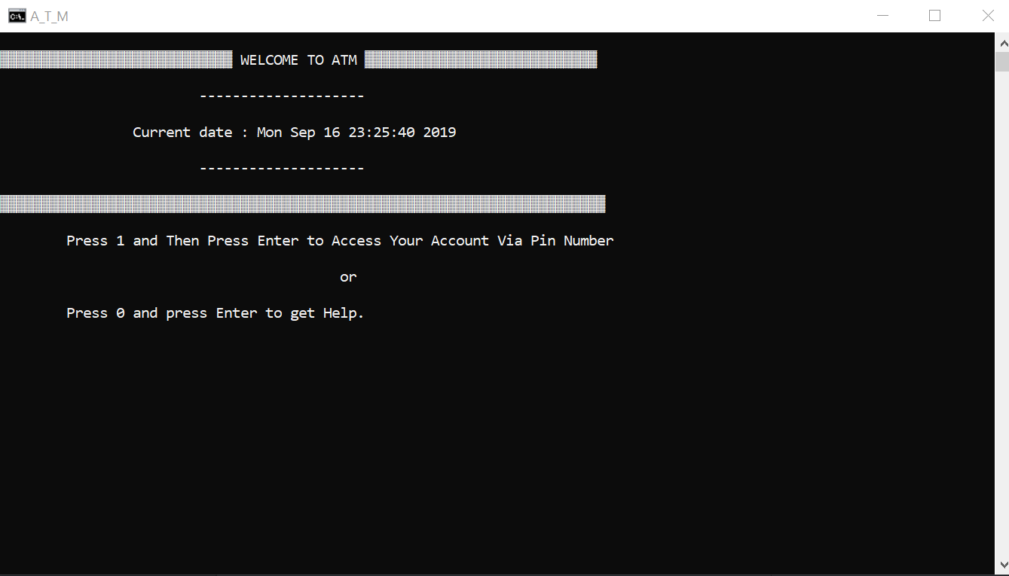
ENTERING THE PIN:
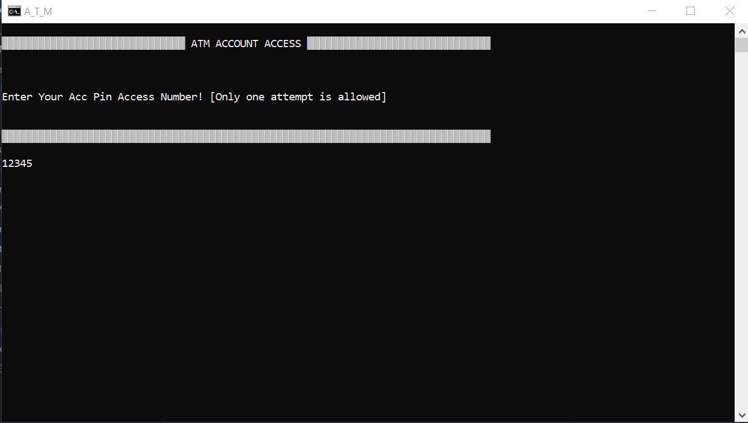
DETAIL OF THE ACCOUNT HOLDER: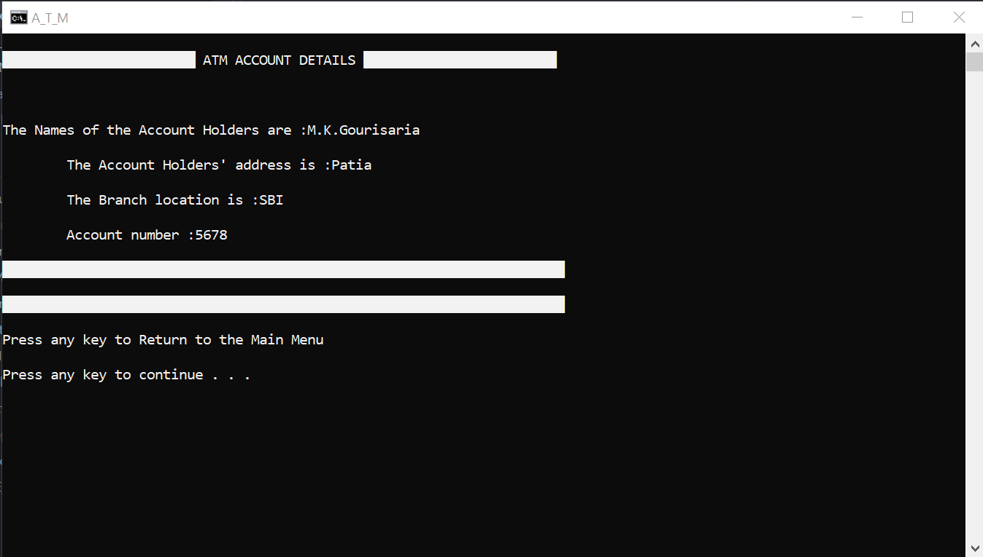
CHANGE PIN:
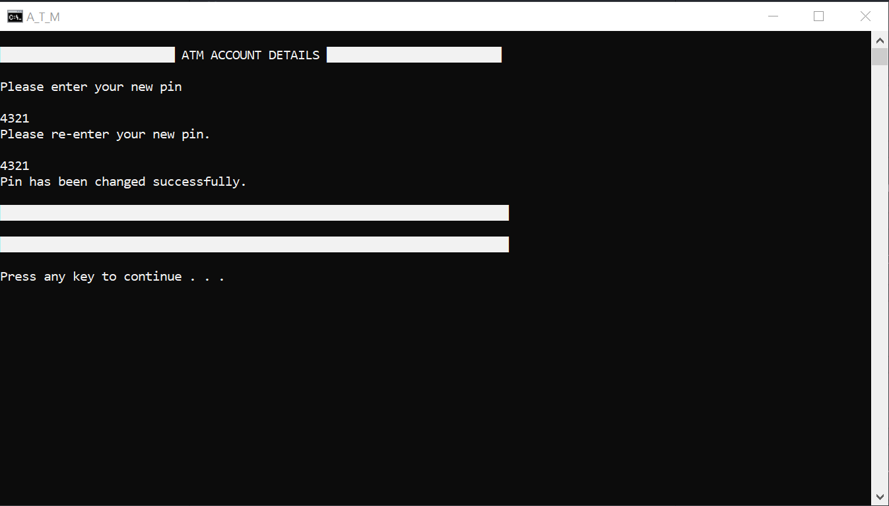
BEFORE WITHDRAW: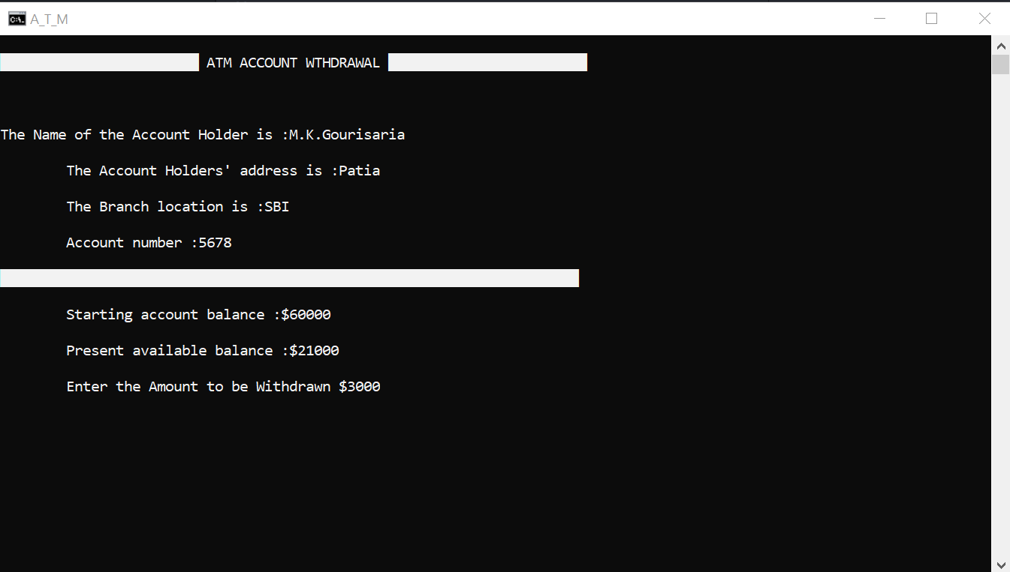

DEPOSIT:
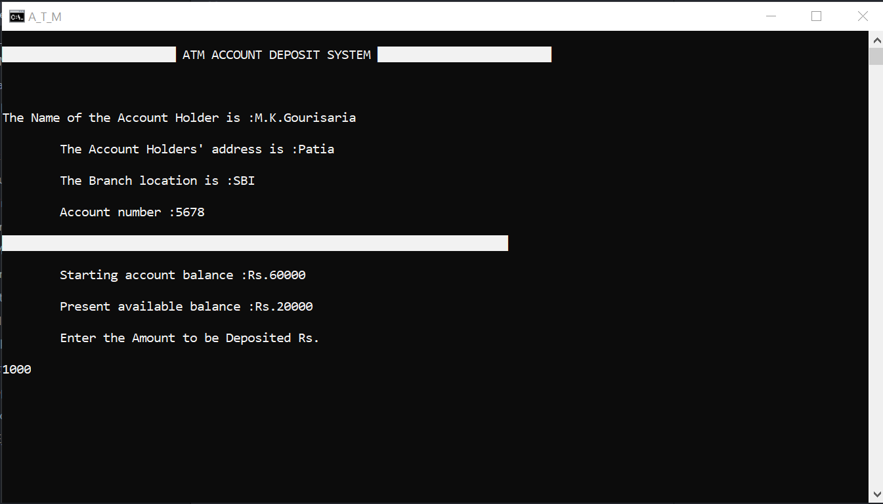
AFTER WITHDRAW: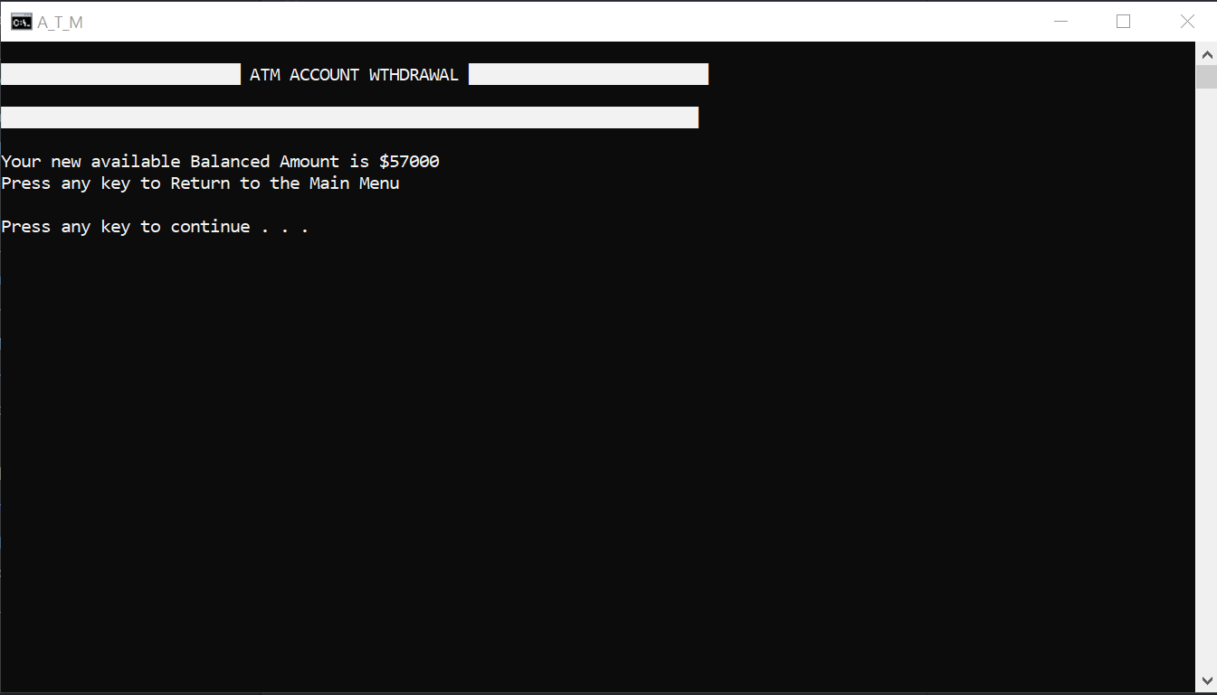
EXIT:
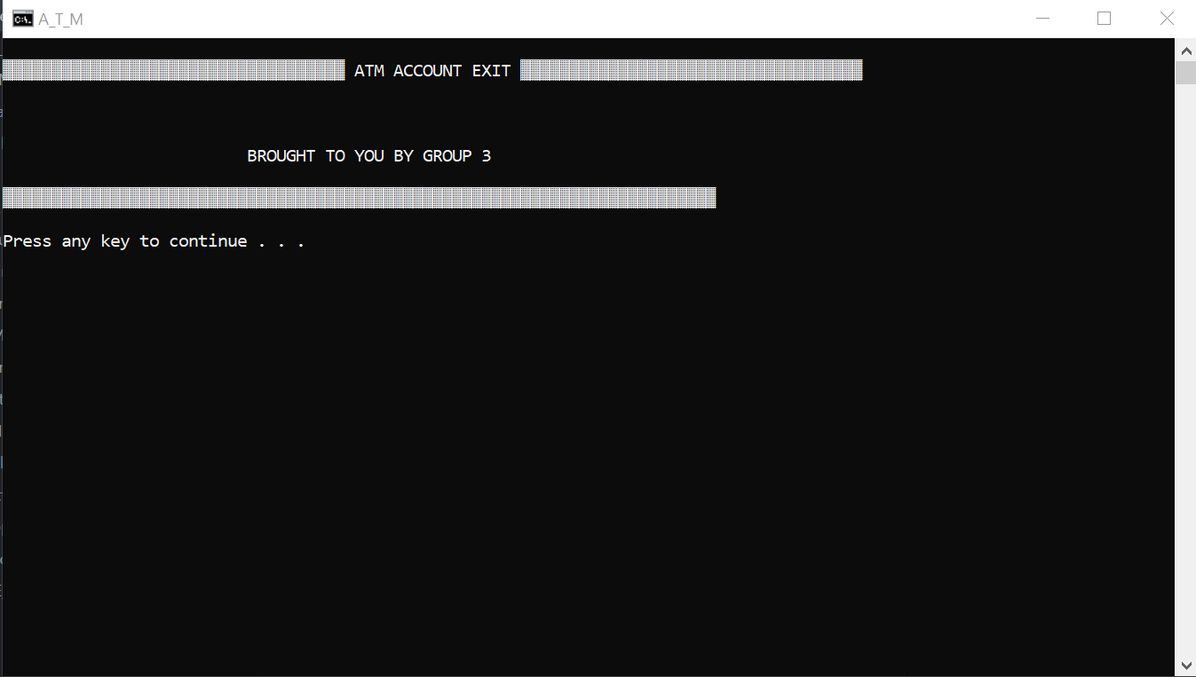

LIMITATIONS

Although I have tried to add all the related features to this Automatic Teller Machine, but there are also some limitation. This system is stand alone system so data saved during different processes are stored in the machine in which that process was executed. So there is the problem of distributed database.

SCOPE OF IMPROVEMENT

As discussed the limitation of this system, we can implement this as client/server system. So all the data will be stored in the single machine, and for any purpose all the data will be retrieved from this central database.

CONCLUSION

Back in 1969, Chemical Bank announced that a new form of banking was being launched. With that, customers were provided with plastic cards designed with a magnetic strip that could be used with a machine built into a wall. Gone were the days of having to stand in line for a teller or not having money on hand after normal banking hours. Almost everyone has heard of and used an ATM machine. Interestingly, some of people feel that ATM machines are the best thing to happen in the banking world while other people consider them a curse. The main complaint heard about ATM machines is that while they are convenient, they are expensive to use. However, if we look at it from a banking perspective, business is business. Regardless of what we think of ATM machines, there is no doubt that they have changed the world and the way in which we do things. For example, think how many times we have been out somewhere only to discover we have no cash and we are out of checks, ah, but in the corner, there is an ATM machine. In the blink of an eye, we swipe the card and now have cash on hand. In addition to pulling money out, the ATM machine also makes it convenient to deposit money, transfer money, and check balances. Best of all, to use an ATM machine, we do not have to go to the bank. We will find ATM machines at other banks, grocery stores, shopping malls, along the roadside, airports, in casinos. For this reason, ATM machines are extremely helpful!

BIBLIOGRAPHY

#BOOK REFERENCE
- E BALAGURUSAMY(OOP C++)

#WEBSITE REFERENCE
1. www.google.com
2.www.ask.com
3.www.microsoft.com
4.www.iit.edu.com
5.https://www.google.com/search?q=atm+management+system&oq=ATM+MANA&aqs=chrome.1.69i57j0l5.9637j0j7&sourceid=chrome&ie=UTF-8

